BIO 2117 Oral Presentation: Script

Name of Group Members
Institution of Affiliation
Course
Professor
Date

Introduction to the disease
Background: Discovery of the Disease (WHO, WHERE, WHY, HOW)
Gonorrhea had been in existence for years back throughout the world’s history with the disease being referred to as “gonorrhea”, a word of Greek origin gono meaning “seed,” and rhoe, “flow,” because early physicians incorrectly thought the purulent discharge was semen (Kurylo, 2016). As early as 1719, gonorrhea was referred to as “the clap” with many varying theories as to why it was referred this way. One of the most interesting theories is one that depicts the term “the clap” being synonymous with old French clapier, meaning “brothel,” a place where the disease spread easily (Kurylo, 2016). Another amusing theory refers to the pre-antibiotic days when the infection was treated by slapping the penis against a board, or clapping it between two boards to force out infected discharge (Kurylo, 2016).
For many years, scientists had been dealing with a baffling dilemma of whether gonorrhea and syphilis were variations of the same disease. The journey of discovery of this disease and its causative agent began in the eighteenth century with John Hunter, a brilliant English surgeon. John Hunter is known for his heroic act in attempts to prove the thesis of the two disease being variations of the same disease. He inoculated his own skin with infectious material from the urethra of a young man presumed to have gonorrhea, and thus he contacted syphilis from which he later died having erroneously “proved” that gonorrhea and syphilis were variations of the same disease (Stuart et al., 2016). This heroic experiment, despite criticism and contrary opinion that he might have in fact inoculated another man and not himself, added nearly a century to the confusion over the identities of the two diseases with the confusion being clarified by Philippe Ricord in 1831 who inoculated several hundred human volunteers with gonorrhea without producing syphilis (Stuart et al., 2016). But it was not until 1879 that the diseases were confirmed to be two different entities by the discovery of gonococcus in 1879 by Albert Neisser followed definitively by the discovery of Treponema pallidum by Schaudinn and Hoffman in 1905 which put to an end the question as to the separate identities of the two diseases (Stuart et al., 2016).
Albert Neisser isolated and visualized N. gonorrhoeae diplococci in samples of pus from 35 men and women with the classic symptoms of genitourinary infection with gonorrhea – two of whom also had infections of the eye (Stuart et al., 2016). His findings were confirmed in 1883 by Max Bockhart who proved conclusively that the bacterium isolated by Albert Neisser was truly the causative agent of the disease gonorrhea by inoculating the penis of a healthy with the bacteria (Stuart et al., 2016). The man developed the classic symptoms of gonorrhea days after satisfying the last of Koch’s postulates. The bacteria Neisseria was consequently named after Albert Ludwig Sigesmund Neisser, the German physician who discovered Neiserria gonorrhoeae (Kurylo, 2016). However, Information about WHERE he made the discovery is not available. Subsequent to its discovery, the gonococcus was first cultivated by Leistikow and Loeffler in 1882, but more satisfactorily grown and studied by Bumm in 1885. Its identification was greatly simplified by the introduction of the Gram stain, the only significant contribution to science by Hans Christian Joachim Gram in 1884. Its differentiation from other Neisseria was subsequently made possible by the application of sugar fermentation, and in 1911 Schwartz and McNeil applied the principle of complement fixation to the diagnosis of gonorrhea (Stuart et al., 2016).
Causative Agent
The causative agent of the disease is a bacterium, Neisseria gonorrhoeae, one of the only two Neisseria species that is pathogenic to humans (Kurylo, 2016). The second, Neisseria meningitides, causes outbreaks of meningitis and septicemia. It was isolated by Anton Wiechselbaum in 1887 and designated as Diplococcus intracellularis meningitides (Kurylo, 2016).
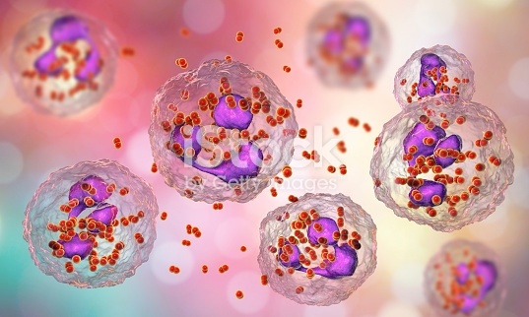
Image: Bacteria Neiserria gonorrhoeae inside phagocytes, gonococcus, diplococci which cause sexually transmitted infection gonorrhea. 3D illustration of incomplete phagocytosis. Courtesy of Essentials Collection
The unique characteristics of this bacterium, N. gonorrhoeae, are:
- It is gram-negative, non-motile, intracellular diplococcal bacterium
- Has the ability to survive inside neutrophils (Stuart et al., 2016).
- It can be killed rapidly by drying, sunlight, heat, and disinfectants.
- It ferments carbohydrate producing acid but no gas.
- Each cocci is kidney-shaped with adjacent concave sides.
- It is a fastidious bacterium that grows best on complex media such as enriched agar(chocolate agar) with various antimicrobials (Thayer-Martin) under aerobic conditions containing 5% CO2
- It is oxidase positive.
- It is an obligate parasite of the human urogenital tract.
- It exhibits antigenic variation through recombination of its pili and surface proteins that interact with the immune system increasing its pathogenicity as its mechanism to evade the immune system (Stuartn et al., 2016).
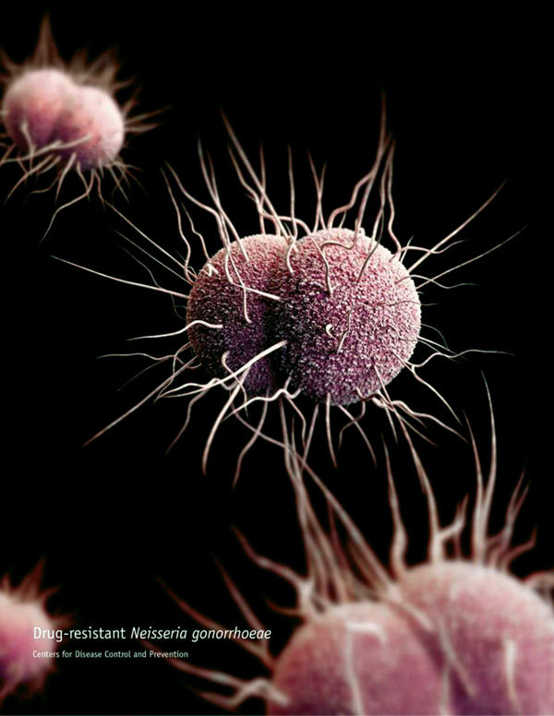
Image: A 3-dimensional computer-generated image of drug-resistant Neisseria gonorrhoeae diplococcal bacteria. Source: Public Health Image Library.
Antigenic structure: It is antigenically heterogeneous and capable of changing its surface structures (antigenic variations).
  - Pili: Hair-like appendages extending from bacterial surface and enhance attachment to host cells and evade human defense. The pili of almost all strains of N. gonorrhea are antigenically different, and a single strain can make many antigenically distinct forms of pilin.
  - Por (Protein I). Pores on the surface of bacteria through which nutrients enter the cell.
  - Opa (Protein II). Important for attachment of bacteria to host cells.
  - RMP (Protein III): Reduction-modifiable protein. It is associated with por in the formation of pores in the cell.
  - Lipo-oligosaccharide (LOS): Responsible to damage epithelial cells.
N/B: Toxicity in gonococcal infection is largely due to the endotoxin effects of LOS
  - LiP (H8): Gonococcal surface exposed Heat-Modifiable like Opa
  - Febp (Iron binding protein):Expressed when there is limited available iron supply
  - IgA1 protease: Splits and inactivates major mucosal IgA(IgA1)
Symptoms of the disease
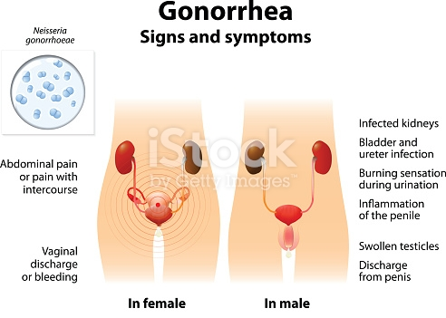
Image: Male and Female silhouette with highlighted internal organs warning signs. Courtesy of Essentials Collection. Insert: Micrograph of N. gonorrhoeae
Vary depending on the gender and site of infection.
In males it manifests as Gonococcal urethritis. If complicated it can give rise to Urethral stricture, Gonococcal epididymitis, and Gonococcal epididymo-orchitis, which all result in Infertility, and the rare Gonococcal suppurative arthritis (septic arthritis) and disseminated gonococcemia that can occur resulting in endocarditis, meningitis, or gonococcal dermatitis-arthritis syndrome.
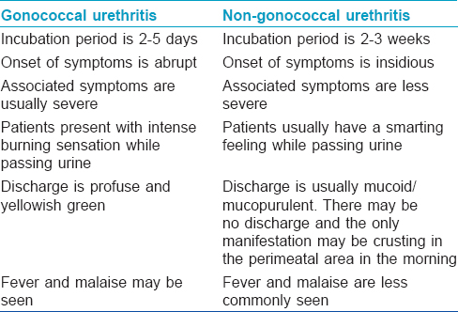
Image: Courtesy of the Indian Journal of Dermatology, Venereology, and Leprology
In females it manifests as gonococcal cervicitis (inflammation of the cervix) and Gonococcal salpingitis (inflammation of the fallopian tubes). If complicated it can lead to Gonococcal tubo-ovarian abscess, pelvic peritonitis (Pelvic Inflammatory disease), and infertility which is a risk to 10-20% of the females infected with N. gonorrhoeae.
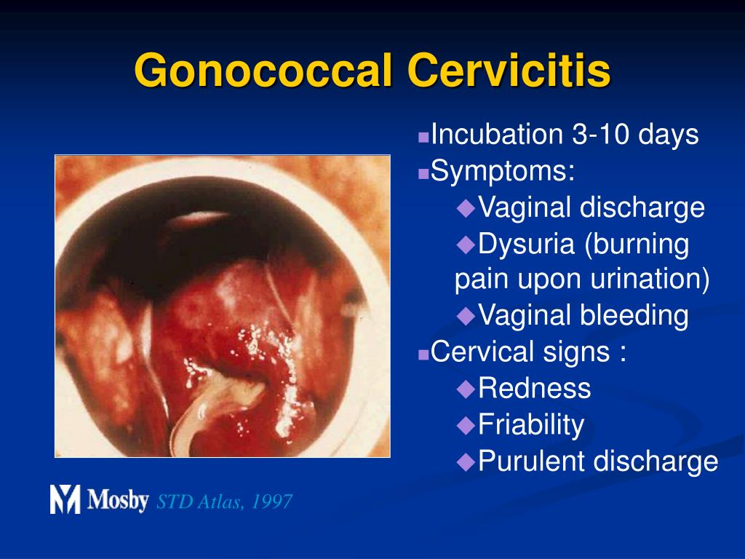
In infants (When delivered through the infected birth canal) they can get infected in which case the disease will manifest as Gonococcal ophthalmia neonatorum affecting the eyes. If untreated and complicated, it leads to blindness.
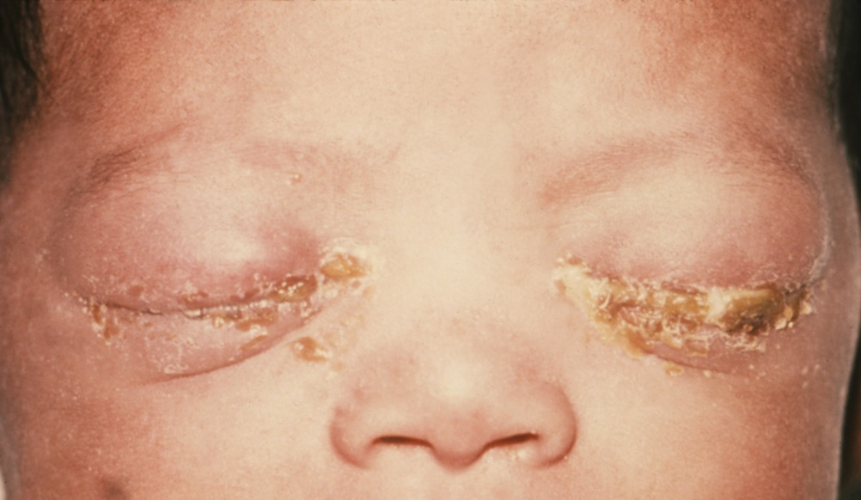
Image: Gonococcal ophthalmia neonatorum
Diagnosis and Treatment
Route of infection:
- Sexual contact (It is a sexually transmitted disease: including all other forms of sex: vaginal, oral and anal) (CDC, 2015). Prevented through the use of barrier protection such as using condoms.
- Perinatal transmission may occur during childbirth. This transmission may be prevented by antibiotic treatment of the mother before birth and the application of antibiotic eye gel on the eyes of the newborn (CDC, 2015).
Laboratory diagnosis:
Specimen: Urine, urethral swab, cervical swab, eye swab
1) Smear: Gram-negative intracellular diplococci with more than five polymorphs per high power field.
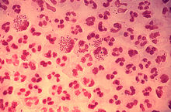
Micrograpgh: Gram-stain of gonococcal urethritis. Note distribution of neutrophils and presences of both intracellular and extracellular bacteria. Courtesy of the CDC.
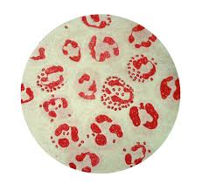
Micrograph: Intracellular diplococci N. gonorrhoeae inside neutrophils.
2) Culture:
- Requires an enriched media like chocolate agar or thayer-martin agar.
- Grows best in CO2 enriched aerobic atmosphere with optimal temperature of 35-37⁰C.
- Fastidious- Dies with exposure to sunlight, room temperature and drying.
- .Gives small glistening colonies.
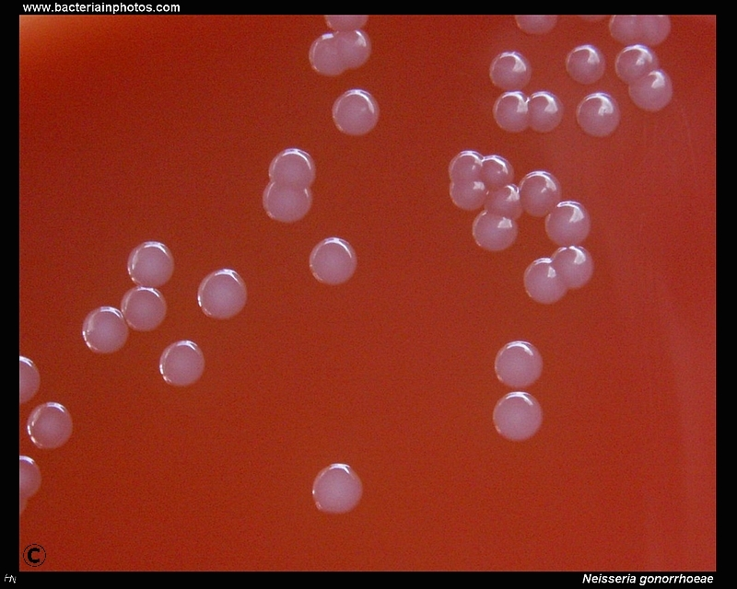
Image: Non-hemolytic colonies of Neiserria gonorrhoeae on a medium with sheep blood, cultivated 48 hours, 37^{O}C, 5% CO₂. Courtesy of www.bacteriainphotos.com
N/B: Culture of urethral exudate from men is not necessary when the gram stain is positive but culture should be done for women
3) Biochemical reaction:
- Oxidase positive.
- Ferment only glucose in carbohydrate utilization test
4) Serology:
Antibodies to gonococcal pili and Omps can be detected by immunoblotting, RIA or ELISA tests
5) Specific PCR for N. gonorrhoeae:
N/B: Chlamydia co-testing and testing for other STI’s is recommended due to high rates of co-infection.
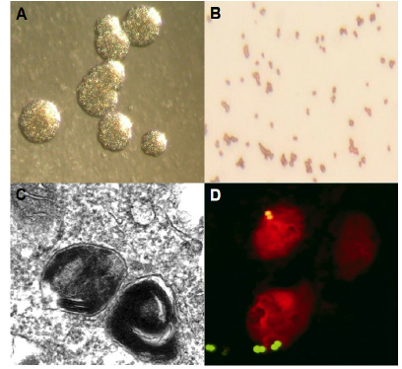
Image: Neisseria gonorrhoeae. (A) Colonies on agar, (B) Gram-Staining, (C) Transmission electron microscopy, (D) Confocal microscopy of the bacteria (in green). Courtesy of Kevin Maisey
Treatment:
Gonorrhea is difficult to treat because of resistance to lots of antibiotics, especially in developing countries.
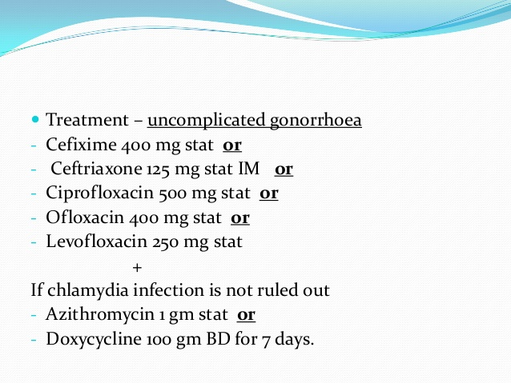
Image: Pharmacologic treatment of uncomplicated gonorrhea. Courtesy of Dr., Shipa Soni, MGMCH.
Incidence
Sexually transmitted infections (STIs) is an area of public health concern for the United States and especially among adolescents age 15-24 years with approximately 20 million new STIs each year, half of the cases of which are among the adolescents (Shannon & Klausner, 2018). From 2015-2016 alone, the rates of N. gonorrhoeae infection increased by 11.3% among adolescents aged 15-19 years and by 10.9% among adolescents aged 20-24 years (Shannon & Klausner, 2018). The prevalence rates of the disease in adolescents age 15-19 years: females 482.1 and males 280.8 cases per 100,000 people (Shannon & Klausner, 2018). The prevalence rates in adolescent’s age 20-24 years: in females 595.5 cases and males 616.8 cases per 100,000 people (Shannon & Klausner, 2018).
Patient Prognosis
The disease is curable but quite problematic to treat as it demonstrates antigenic variations making it highly virulent and with numerous antibiotic resistant strains. Successful treatment leads to full recovery but with lack of treatment, complications ensue some of which might prove to be life threatening such as the disseminated gonococcemia that often leads to septic arthritis.
Current and Future Scientific Research
Current research is focusing on:
- the antimicrobial resistance of N. gonorrhoeae (Workneh et al., 2020),
- stopping the disease and preventing its resurgence (Brazil, 2020),
- its epidemiology (incidence and prevalence rates across population subgroups) and likelihood of co-infections with Chlamydia (Louis et al., 2020), and
- on including sexual and reproductive health and rights under universal health coverage (Lince-Deroche et al., 2020).
Future Research: Could endeavor to deduce more potent antibiotics to treat infections with the antibiotic resistant strains. Also, should look for ways to arrest the antigenic variations that go on in the bacteria making it a lot more virulent.
Why Gonorrhea?
Mainly because of the considerably grave complications that can arise from one such untreated infection with the disease coupled with the rising incidences of the disease and among the adolescents; it makes for a considerable Public Health concern.

Bibliography
Brazil, R. (2020). Stopping the Spread: Ending the Resurgence of Gonorrhea. The Pharmaceutical Journal.
Centers for Disease Control and Prevention (CDC) (2015). 2015 Sexually Transmitted Diseases Treatmnet Guidelines: Clinical Prevention Guidance. Retrieved from https://www.cdc.gov/std/tg2015/clinical.htm
Kurylo, E. (2016). Etymologia: Neisseria. Emerg Infect Dis., 22(6): 1141
Lince-Deroche, N., Sully, E. A., Firestein, L., & Riley, T. (2020). Budgeting for comprehensive sexual and reproductive health and rights under universal health coverage. Sexual and Reproductive Health Matters.
Louis, J. F., Galbaud, G., Leonard, M., Pericles, E., Journel, I., Buteau, J., Boncy, J., Francois, J. R., & Domercant, W. J. (2020). Prevalence of Neisseria gonorrhoeae and Chlamydia trachomatis in men having sex with men in Port-au-Prince, Haiti: A Cross-Sectional Study. BMJ Open, 10(3): e033976
Shannon, C. L. & Klausner, D. J. (2018). The Growing Epidemic of Sexually Transmitted Infections in Adolescents: A Neglected Population. Curr Opin Pediatr., 30(1): 137-143
Stuart, H. A., Thao, M. L., & Jenny, W. (2016). Gonorrhea – An Evolving Disease of the New Millennium. Microbial Cell, 3(9): 371-389
Workneh, M., Hamill, M. M., Kakooza, F., Mande, E., Wagner, J., Mbabazi, O., Mugasha, R., Kajumbula, H., Walwema, R., Zenliman, J. et al. (2020). Antimicrobial Resistance of Neisseria Gonorrhoeae in a Newly Implemented Surveillance Program in Uganda: Surveillance Report. JMIR Public Health Surveill., 6(2): e17009

Q & A Questions asked and answered in class during Presentation
Questions: Multiple-Choice Question
1) Who first isolated and visualized the microbe Neisseria gonorrhoeae?
- John Hunter
- Philippe Ricord
- Albert Neisser
- Max Bockhart
2) What is the causative agent of Gonorrhea?
- Treponema pallidum
- Neisseria meningitis
- Chlamydia trachomatis
- Neisseria gonorrhea
3) Which one of the following does NOT constitute possible complications of untreated cases of gonorrhea?
- Gonococcal epididymitis
- Gonococcal urethritis
- Infertility
- Septic arthritis
- Disseminated gonococcemia
4) What is the most common route of transmission of gonorrhea?
- Perinatal transmission
- Sexual contact
- Ingestion
- Inhalation
5) How does Neisseria gonorrhoeae evade the immune system?
- Antigenic shift
- Antigenic drift
- Antigenic variation
- Antigenic recombination

